# CS 255 System Design Document Template

## UML Diagrams

### UML Use Case Diagram

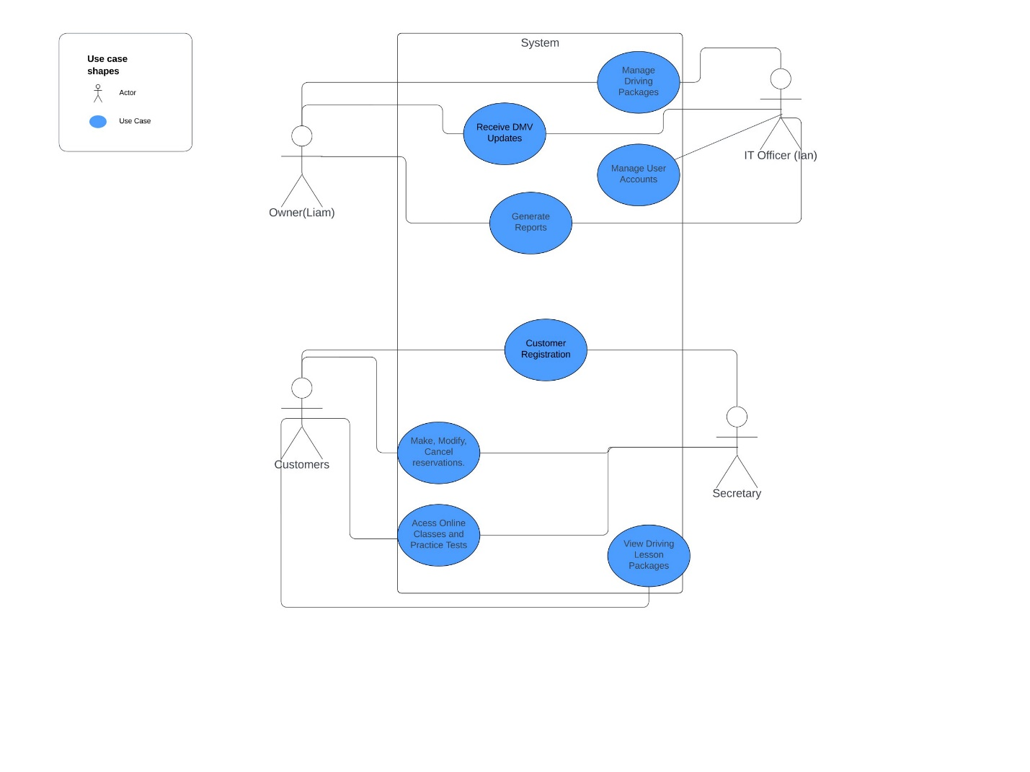

### UML Activity Diagrams

### UML Sequence Diagram

### UML Class Diagram

## Technical Requirements

Hardware:

The Hardware requirements are not state of the art but necessary to be used by the driving school. Servers and backup systems will be required to have online and offline access. It will need to utilize a cloud based system with high availability and redundancy Is recommended to avoid downtime. High powered work computers for the administrators, IT officers, and secretaries to manage the system. This is necessary for employees to interact with our system efficiently, and therefore our customers. Mobile devices will also be necessary, especially for instructors to work with their clients. This includes scheduling, driver notes, and performance tracking during driving lessons. Powerful networking will be needed to keep internet connectivity optimized well.

Software Requirements:

An Operating system for hosting the application and for workstations will be necessary. A powerful database will be required for employee, client, DMV, driving packages, and more. MySQL could be used. Web server software will be needed for client interaction from their location. A language framework will also be needed to create the web application. Lastly, a cloud service will allow backups and optimized storage from one location through internet connectivity. A software that connects to the DMV’s systems would be helpful for auto updating information on our website and such.

Tools:

An IDE(Integrated Development Environment) like visual studio or the like will be necessary for debugging and software creation if we are doing it in house. A security methodology, firewalls, data encryption, use authentication, and more will all be needed to keep client and worker information secure. Secure connections trough SSL/TLS Certificated is helpful for securing connections.